**Key Questions**

**History:**

1. When were the pyramids built?
2. Why was the Nile important in Ancient Egypt?
3. What was daily life like in Ancient Egypt?
4. What were the religious beliefs of Ancient Egypt?

**Science:**

1. Can you identify and name the parts of the human digestive system.
2. What are the functions of the organs in the human digestive system.
3. Describe the functions of different human teeth.

**Computing:**

What is an algorithm?

**Art:**

Who is David Hockney?

**DT:** What is a mechanical Shaduf?

Egypt’s development was intricately tied to the Nile River, which provided water, fertile soil for agriculture, and a transportation route. The regular flooding of the Nile ensured abundant crops and supported a complex society.

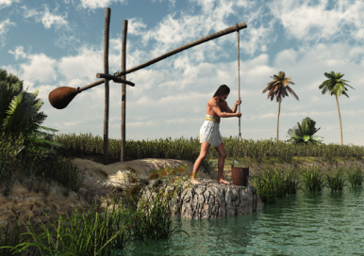

Ancient Egypt, one of the oldest and most influential civilizations in history, flourished along the northeastern coast of Africa, primarily in the fertile Nile River Valley. The civilization lasted for thousands of years, from around 3100 BCE until Alexander the Great's conquest in 332 BCE, and it continues to captivate the world today due to its rich cultural, architectural, and artistic achievements.

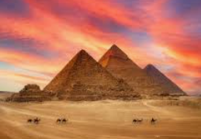

**Egypt**

**Design and Technology**

Tomb Raiders – Topic 3 (Class 3)

**Key Vocabulary**

Oesophagus large intestine Sustainable small intestine Nile Pharaoh Egypt Hieroglyphics mummification

stomach digestive system gall bladder liver peristalsis saliva absorb algorithms

|  |
| --- |
| Topic Tasks |
| Create a poster, fact file, presentation or model based on Ancient Egypt |
| Create your own game. |
| Design or make a useful item to make life easier. |
| Write a letter or diary entry from a Scientist you have researched. |

**Humans and Animals**

**David Hockney**

The digestive system is responsible for breaking down food into nutrients, which the body can absorb and use for energy, growth, and repair. It begins with the mouth, where food is chewed and mixed with saliva to start the process of digestion. The teeth play a crucial role in this process by mechanically breaking down food into smaller pieces, making it easier for enzymes in the stomach and intestines to further break it down. Teeth are specialized for different functions: incisors cut, canines tear, and molars grind food. Healthy teeth are essential for effective digestion and overall health.



David Hockney, a renowned British artist, is well-known for his innovative approach to art, particularly in the realm of photography. One of his most groundbreaking contributions to the medium was his exploration of "pixilated photography" or "joiners" in the 1980s.

In his joiner works, Hockney assembled a series of photographs taken from different angles and perspectives to create a single, composite image.

