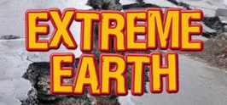
Topic Homework!
Please complete at least one piece by: 18th December.
- Make a volcano out of a material of your choice.
- Create a fact file all about natural disasters.
- Create your own biome in a box.
- Write a diary entry from the perspective of an earthquake survivor.
- Make a tornado in a jar. Write a set of instructions that tell you what to do and explain what a tornado is.
Climate zones
There are 4 major climate zones:
- Tropical zone from 0°–23.5°
- Subtropics from 23.5°–40°
- Temperate zone from 40°–60°
- Cold zone from 60°–90°

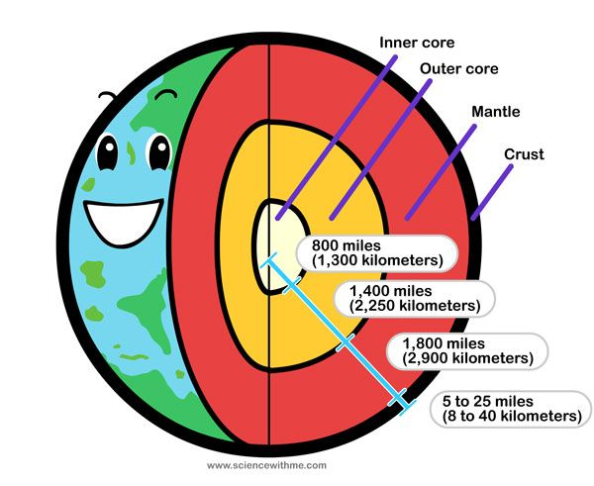
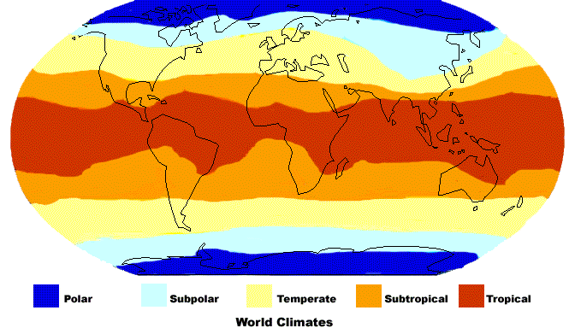

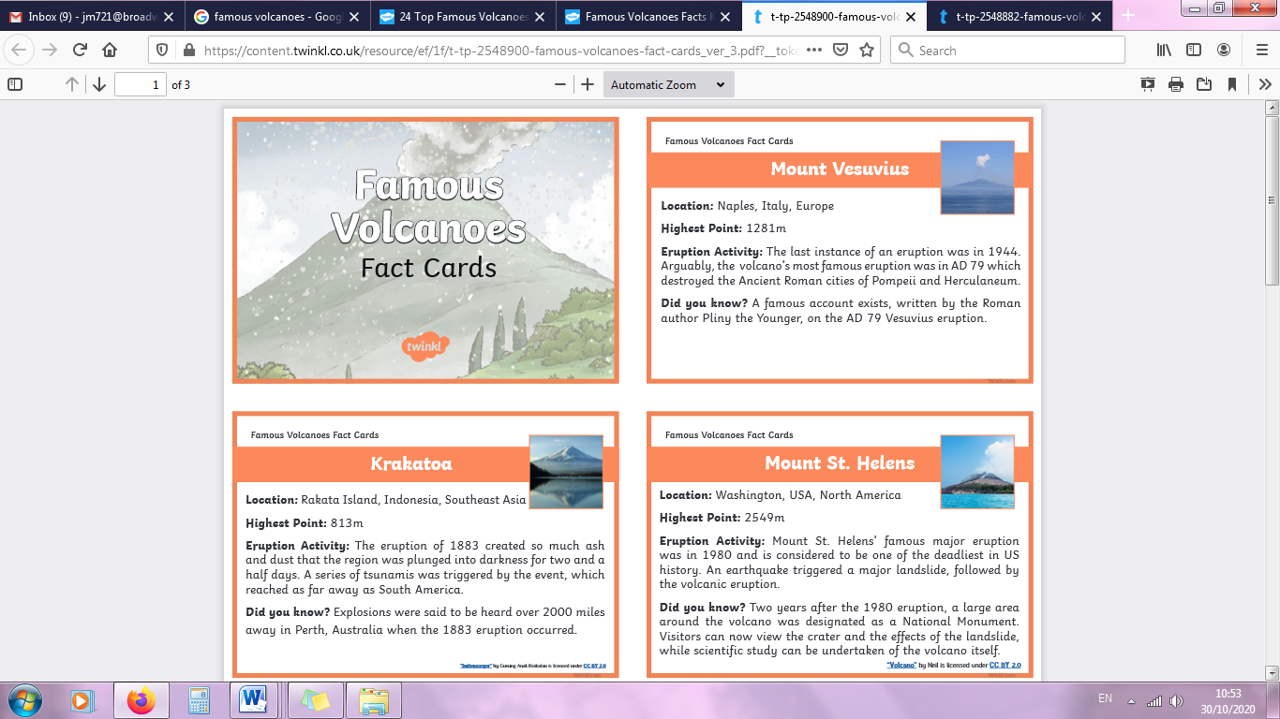

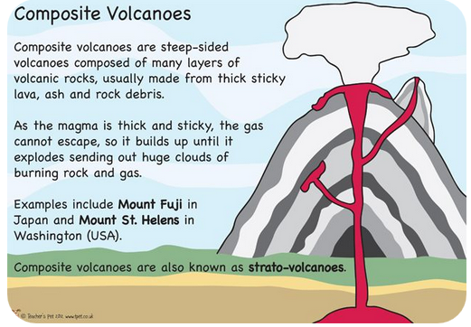
Key questions
- Explain how an earthquakes and volcano occur in as much detail as you can.
- What is the ring of fire?
- Name the 6 main biomes. Which of these could be found in South America?
- How has land-use in the Amazon rainforest changed over time?
- Can you explain how magnets work?
- What is the difference between a contact and non-contact force?
- Describe the function of a flowering plant.
- Name techniques used in stop-frame animation.
- What style of art does Henry Matisse do?
- In French, describe your family members.

Key vocabulary
Active volcano Composite volcano
Compound volcano Extinct volcano
Dormant volcano Biome
Core Crater
Crust Lava
Magma chamber Mantle
Earthquake Richter scale
Tsunami Tectonic plates
Epicentre Mercalli scale
Arid Tropical
Climate zone Ring of fire

Italy, 2020
Fukushima, 2011
Nepal, 2015
Haiti, 2010
Tohoku, 2011
Aegean, 2020
Earthquakes

